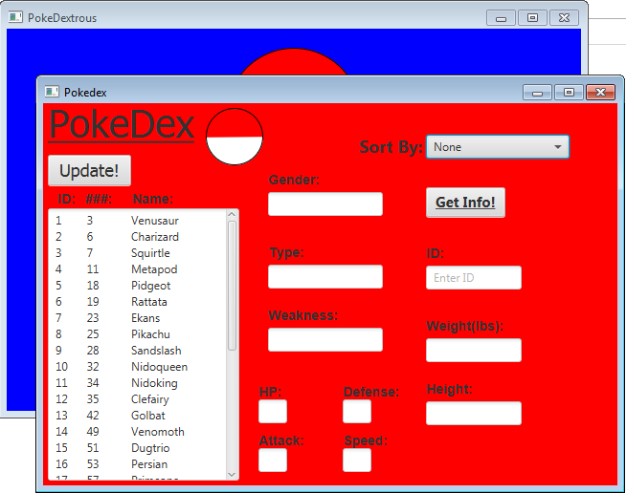
Ryan Goscinski
PokeDextrous Test Plans
- Click on the “PokeDex” button on the main screen.
- This pop-up window will appear:
- The table will have retrieved the data from the databse of
real pokemon.
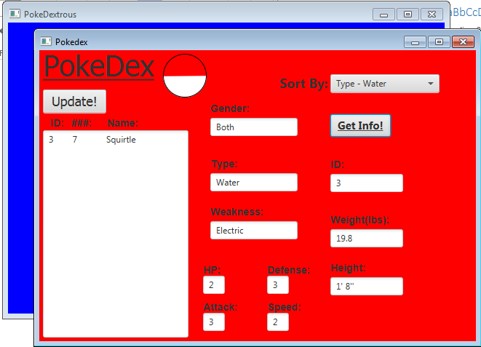
- Use the “Sort By:” combo box to select a sort condition.
- Click the “Update!” button to update the table data.
- Select one of the pokemon from the table and enter
the ID number into the “ID:” text box.
- Click the “Get Info!” button to retrieve all of the
pokemon’s statistics from the database.
- This completes the functionality of this portion of the application.
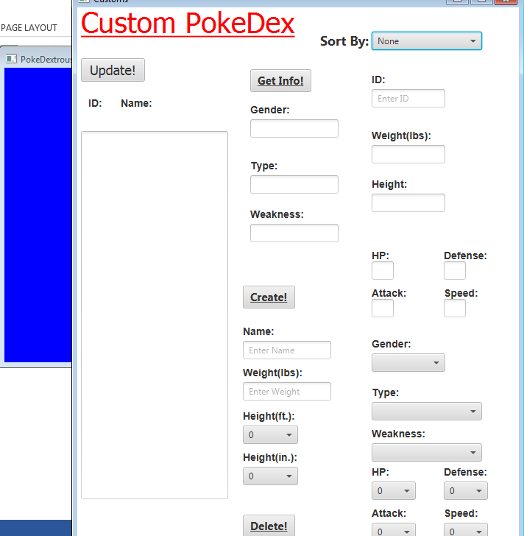
  - Close the “PokeDex” window.
- Click on the “Customs” button on the main screen.
- This pop-up window will appear:
- The table will be empty because no custom pokemon
exist.
- Create a pokemon by entering a name, then fill in
the rest of the text and combo boxes.
  - Click the “Create!” button when all fields are filled.
- The newly created custom pokemon will appear in the table.
- Enter the ID number of your custom pokemon into the “ID:” text box.
- Click the “Get Info!” button to retrieve your custom pokemon’s statistics:
- Make a new custom pokemon, but when creating it, DO NOT fill in the “Type:” combo box.
- Click “Create!” to demonstrate the proper exception handling.
  - This will not allow the user to make a “bad” custom pokemon.
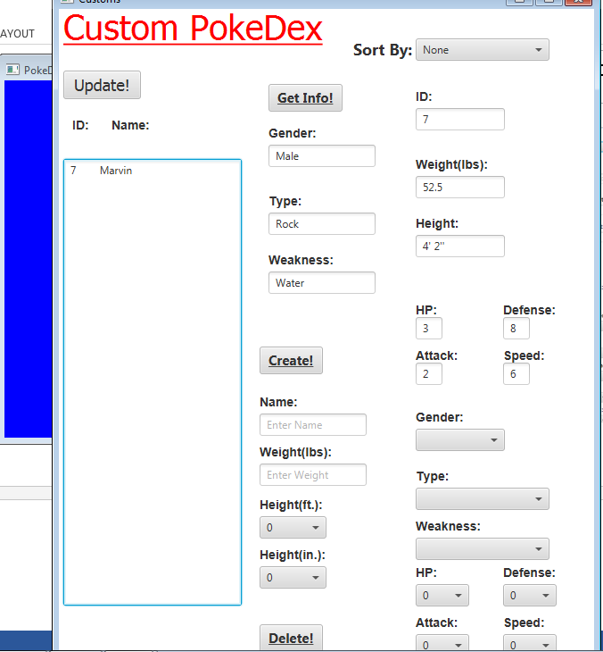
- Enter the ID number of a custom pokemon into the “ID:” text box and click the “Delete!” button to erase the custom pokemon from the database.
- This completes the functionality of PokeDextrous.

References: http://www.pokemon.com/us/pokedex/
Approx hours of work: 30h

